**Thomas Martin**

**CS-360-16228-M01 Mobile Architect & Programming**

**4-4 Assignment: UI Design**

**Southern New Hampshire University**

**September 28, 2024**

For this assignment, I chose to focus on Sortly, an inventory management app I am using for a real company. Sortly is a well-regarded solution that simplifies inventory tracking and organization for both businesses and individuals. The platform allows users to create visual, intuitive catalogs of their items, making inventory management more accessible and efficient. With features such as barcode scanning, customizable fields, and detailed item tracking, Sortly offers users the flexibility to tailor the system to their unique needs. Whether managing a small personal inventory or overseeing stock for a larger business, Sortly enables users to streamline their operations, track stock levels, and maintain accurate records with ease.

Although Sortly is a robust application with a wide range of capabilities, there is always room for improvement. To better align with the needs of the real-world company I’m working with, I have chosen to redesign a key screen within Sortly’s interface: the Dashboard. The purpose of this redesign is to enhance usability and better address user needs. My primary objective is to improve functionality while preserving the simplicity that users appreciate. By addressing specific pain points and incorporating new features that streamline inventory processes, my redesigned dashboard aims to provide a more efficient and user-friendly experience.

Below is a comparison of the original dashboard and my proposed redesign, which focuses on improving user interaction and data accessibility.

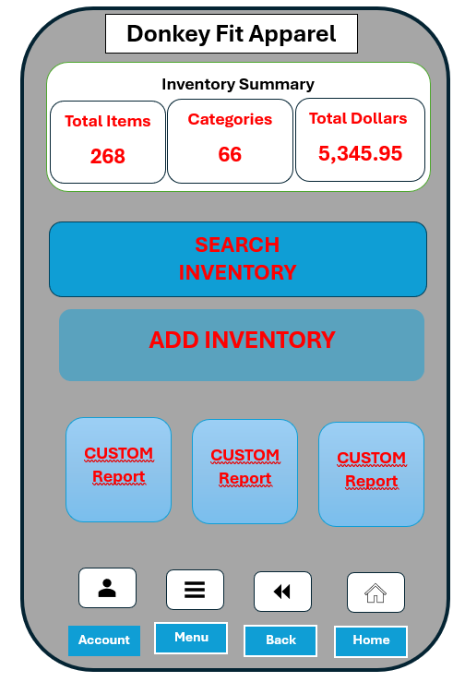

To ensure my redesign aligns with mobile app UI design best practices, I applied several key principles from the readings in the module’s Resources section. These principles include a minimalist design focused on core functions, simplifying data presentation, and ensuring touch-friendly interactive elements, such as buttons and input fields, are appropriately sized for easy interaction, particularly on smaller screens.

In the redesigned Sortly dashboard, I incorporated the following key elements:

Inventory Summary (Top Section): This provides users with a quick snapshot of their inventory's status, displaying total items, categories, and overall value. The concise format allows users to make informed decisions at a glance.

Search Inventory Button: A prominently placed button that enables users to easily search for specific items in the inventory. Its size and location make it highly accessible, improving user efficiency.

Add Inventory Button: This button simplifies the process of updating inventory by allowing users to quickly add new items or categories. By reducing the number of steps needed, it enhances the overall user experience and streamlines operations.

Customizable Report Buttons: Three customizable buttons allow users to generate their most frequently used reports quickly. Whether it’s a sales report or inventory valuation, these buttons provide flexibility and improve workflow by giving users easy access to vital information.

Bottom Navigation Bar: A user-friendly navigation bar offers quick access to:

Account Button: Directs users to account settings or their profile.

Menu Button: Opens a menu for additional features and settings.

Back Button: Allows users to return to the previous screen.

Home Button: Takes users back to the main dashboard or home screen.

The overall design prioritizes simplicity and functionality, with customizable options and a user-friendly layout. By focusing on the most critical functions and streamlining interaction points, the redesign enhances both efficiency and usability.